Todd Hopkins

Hopkitj@g.toiohomai.ac.nz

Abstract

To create a design, build and test a small web application using both client and server-side technologies and a web server scripting language.

Web Application Design  
Assignment

Assignment 1 – Semester 1 2019

Table of Contents

Part A: Site Outline/Scope 2

Part B: Database Implimentation 3

Index/Files 4

3 x SQL Tables in .txt format 4

3 x SQL Tables in .sql format 4

ERD Data Model Design in PDF format 4

ERD Data Model Design in Draw.io format 4

Hi-Fidelity Wireframes for Mobile (Form page included) 4

Hi-Fidelity Wireframes for Tablet (Form page included) 4

Hi-Fidelity Wireframes for PC (Form page included) 4

Lo-Fidelity Wireframes for Mobile (Form page included) 4

Lo-Fidelity Wireframes for Tablet (Form page included) 4

Lo-Fidelity Wireframes for Pc (Form page included) 4

Measurements Colours And Fonts 4

Moodboard logo And colours 4

Site-Map 4

Storyboard 4

SQL querys in .sql format 4

SQL querys in .txt format 4

# Part A: Site Outline/Scope

This document will be presenting a website and website specifications for a new company called Tech Inspect based here in Tauranga. Tech Inspect is a small IT company that does computer repairs, software installations, hardware/software installation, sell low end computers, computer optimisation and other services. While this document and website is in the design process the developer Todd Hopkins will be using the Agile methodology and therefor be getting feedback from the client after each phase of development.

The first phase in this development lifecycle was the low fidelity wireframes. The developer make use of lo fidelity wireframe templates of website that is to be designed and eventually built for the company. The low fidelity wireframes were used to give the client and developer an idea for the positioning of elements on each template page. The feedback that was received from the client at this phase is that they liked the positioning of the elements on the page and the developer was given the go ahead for a full mock-up of the website. There is a preview below of to see all 4 templates click the file extension.

Preview of low-fidelity wireframes:

[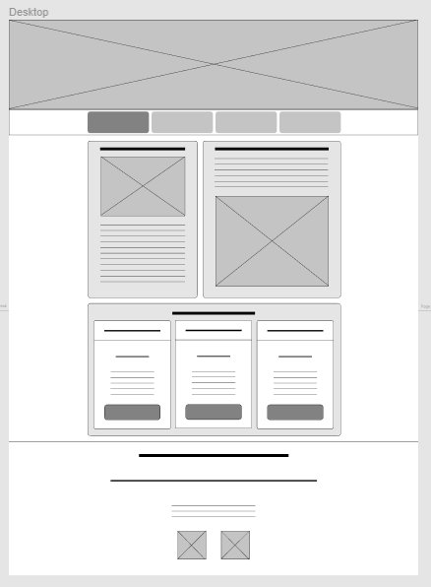](Lo-Fi%20PC.pdf)[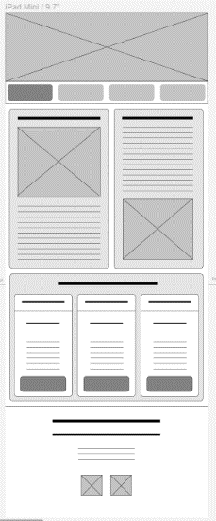](Lo-Fi%20Tablet.pdf)[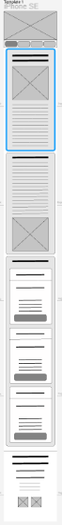](Lo-Fi%20Mobile.pdf)

Double Click to see full file:







The next phase in this development was the mock-ups or high-fidelity wireframes. In this phase a mood board was created to get a feel for the colour scheme which was approved by the client. After the colour scheme was approved the team got to work to develop a logo for Tech Inspect. The Logo was made using website called WIX. The mood board and logo can be found below by double clicking on the file or you can see the preview below:

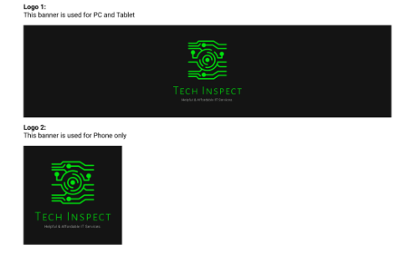

Preview of Mood board and wireframes:

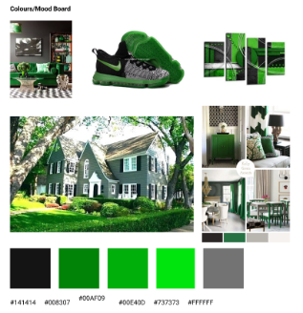Double Click to see file:



Once the mood board, colours, and logo had been approved by the client production went to the next phase which was the designing of a mock-up also known as high fidelity wire frames. High fidelity wireframes are similar to low fidelity wireframes except colours, pictures and logos are used to represent what the final product will look like. Hi fidelity wireframes are used and are used in the industry to get a feel for the website before the coding starts. Feedback from the client can be gained and if the client is not happy then changes can be made to the design easily. In this phase of the design measurements had to be obtained to adhered to in the design. The full high-fidelity wire frames and measurement are included in the file extentions below or view the preview:

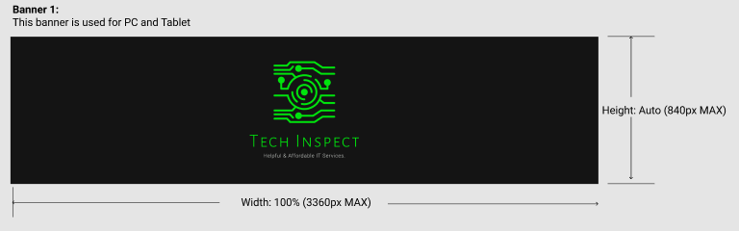

Double Click to see file:



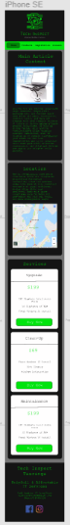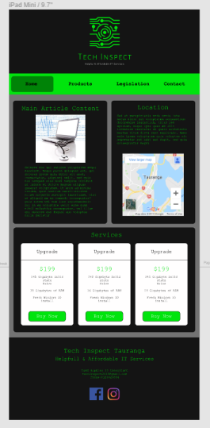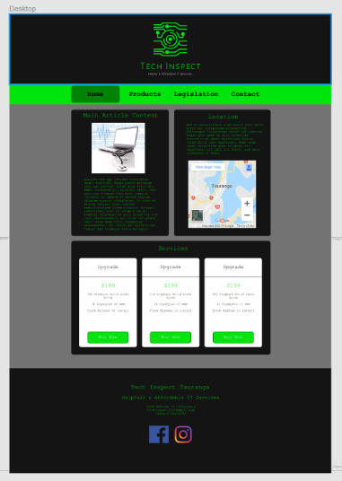





The next step in this development stage was to go through the particulars with the client. This is part of the GUI design and enables the client to see what each part of the website will do. This step also required a design of how the website was going to be structured also known as a sitemap. The sitemap includes all pages on the website and documents all the links between. Story board and site- map are below as follows double click on the file extention to see the full versions or voew the previews below:

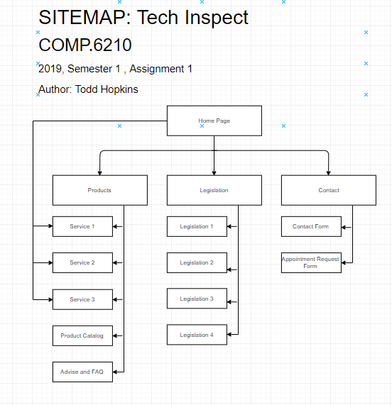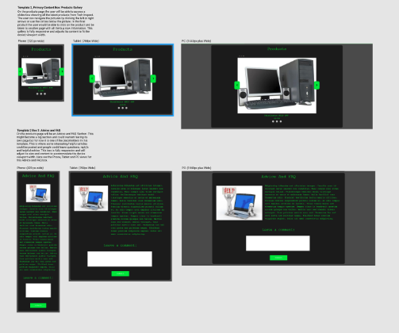Double Click to see file:





Once the website had been designed (including the form pages shown in the above in Hi and Lo-fidelity wireframes) a database model had to be designed based on the contact and appointment sections. The whole website was included into this database model so at a later time the content cou be pulled from another database and put into the content sections of each page replacing the placeholder content. The database model can be found in .pdf format or .xml (draw.io) below:

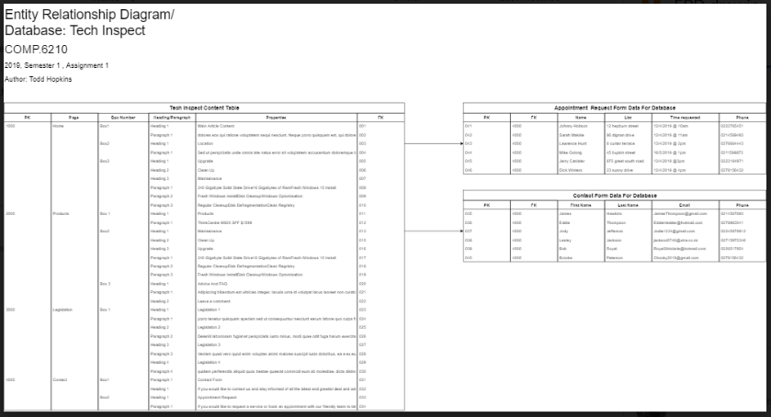

Double Click to see file:





# Part B: Database Implementation

These data models were then created and made into SQL scripts. They are based on the ERD data model above. One file is to make the Database Tables and the other is the SQL query scripts which are to be run on the data tables once they are created.

Double Click to see file:





  


# Index/Files

3 x SQL Tables in .SQL format

[3 x SQL Tables in .TXT format](Sql_Tables_x3.txt)

ERD Data Model Design in Draw.io format

[ERD Data Model Design in PDF format](ERD.pdf)

[Hi-Fidelity Wireframes for Mobile (Form page included)](Hi-Fi%20Mobile.pdf)

[Hi-Fidelity Wireframes for PC (Form page included)](Hi-Fi_PC.pdf)

Hi-Fidelity Wireframes for Tablet (Form page included)

[Lo-Fidelity Wireframes for Mobile (Form page included)](Hi-Fi%20Mobile.pdf)

Lo-Fidelity Wireframes for Pc (Form page included)

[Lo-Fidelity Wireframes for Tablet (Form page included)](Lo-Fi%20Tablet.pdf)

[Measurements Colours And Fonts](Measurements_colours_and_fonts.pdf)

[Moodboard logo And colours](Moodboard_logo_And_colours.pdf)

[Site-Map](SiteMap.pdf)

[Storyboard](Storyboard.pdf)

[SQL querys in .SQL format](Sql_querys.SQL)

[SQL querys in .TXT format](Sql_querys.txt)

# References

AJM Computer Services, 2019, *help.jpg, Retrieved* From: <http://www.ajm-computer-services.co.uk/>

Freepik 2019, *fbk.png, Retrieved* From: <https://www.freepik.com/free-icon/facebook_928938.htm>

Freepng.es 2019*, Img3.jpg,* Retrieved From: <https://www.freepng.es/png-2rxvg7/>

Indiamart 2019, *img1.jpg,* Retrieved From: <https://dir.indiamart.com/varanasi/desktop-computer.html>

Kisspng 2019*, Img2.jpg,* Retrieved From: <https://www.kisspng.com/png-dell-laptop-desktop-computers-all-in-one-computer-668407/>

Shutterstock, 2019, *COMP.jpg,* Retrieved From: <https://www.shutterstock.com/search/medical+equipment+repair>

Supportive Guru , 2019, *igm.png,* Retrieved From: <https://sguru.org/instagram-logo/>